**CONNECTED HOME ENVIRONMENT MONITORING SYSTEM**

***AN INTERNSHIP REPORT***

***Submitted***

*In the partial fulfillment of the requirements for*

*the award of the degree of*

**Bachelor of Technology in**

**Electronics and Communication Engineering**

By

**N PRUDHVI REDDY**

Reg. No. 141FA05099

Under the guidance of Under the guidance of

Mr. Dhanasudakar Vasudevan, Ms. Ashline George

Mr. Vadamalai Ganesh Paramasivam Assistant professor

(Company Mentors)



**DEPARTMENT OF ELECTRONICS AND COMMUNICATION ENGINEERING**

**VIGNAN’S FOUNDATION FOR SCIENCE, TECHNOLOGY AND RESEARCH UNIVERSITY**

**VADLAMUDI, GUNTUR – 522 213, INDIA. NAAC ’A’ Accredited**

**May-2018**

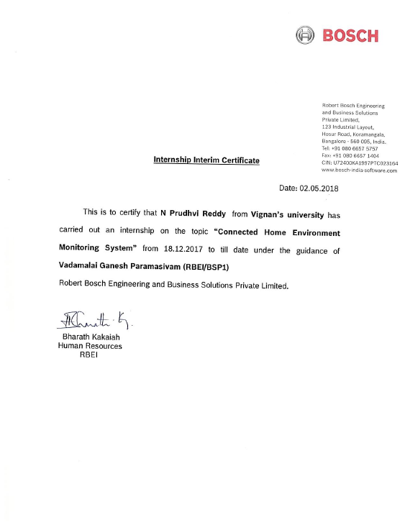

**CERTIFICATE**

This is to certify that the internship report entitled **”CONNECTED HOME ENVIRONMENT MONITORING SYSTEM”** that is being submitted by **N PRUDHVI REDDY** bearing **141FA05099** in partial fulfilment for the award of B.Tech degree in Electronics and Communication Engineering to Vignan Foundation for Science Technology and Research University, is a record of bonafide work carried out by them at **Robert Bosch Engineering and Business Solutions Private Limited** under the supervision of **Dhanasudakar Vasudevan, Vadamalai Ganesh Paramasivam** and the internal guidance of **Ashline George** of ECE Department.

Signature of the faculty guide Signature of Head of the Department

Ms. Ashline George Mr. T. Pitchaiah Assist. Professor Assoc. Professor

**DECLARATION**

I hereby declare that the internship work entitled **“CONNECTED HOME ENVIRONMENT MONITORING SYSTEM”** is being submitted to Vignan Foundation for Science, Technology and Research, University, in partial fulfillment for the award of B.Tech degree in Electronics and Communication Engineering**.** The work was originally designed and executed by me under the guidance of my supervisor **Dhanasudakar Vasudevan,** **Vadamalai Ganesh Paramasivam** with **Ashline George** as faculty guide at Department of Electronics and Communication Engineering, Vignan Foundation for Science Technology and Research University and was not a duplication of work done by someone else. I hold the responsibility of the originality of the work incorporated into this thesis.

Signature of the candidate

N PRUDHVI REDDY

**ACKNOWLEDGEMENT**

The Following People had helped me in this project to complete with perfect product and on time

1. Yanamalamanda Manikanta
2. Mitta Venkata Sindhuja
3. Mitta Sai Soundarya
4. Akshatha Venugopal
5. Sonal DSouza
6. Aliya M
7. Dwivedi Vikas Kumar
8. Meda Bhavya
9. Apineni Ambuja
10. Nayak Sudhindra

N **PRUDHVI REDDY**